PATENT APPLICATION
AI-POWERED DIGITAL TWIN SYSTEM FOR PREDICTIVE INFRASTRUCTURE CONFIGURATION OPTIMIZATION WITH REAL-TIME VULNERABILITY DETECTION

FIELD OF THE INVENTION
The present invention relates to artificial intelligence-based infrastructure management systems, machine learning prediction systems, and automated security vulnerability detection. More specifically, it pertains to a digital twin framework that creates virtual replicas of software infrastructure configurations, predicts performance metrics using trained machine learning models, and identifies security vulnerabilities in software dependencies before deployment to production environments.

BACKGROUND OF THE INVENTION
Modern software infrastructure deployment faces critical challenges in configuration management and security. Traditional approaches require manual trial-and-error testing in production environments, leading to:
- Configuration Risk: Organizations deploy infrastructure changes without predicting their impact, resulting in production outages, performance degradation, and resource waste. Industry studies indicate that 60-80% of production incidents stem from configuration changes.
- Performance Uncertainty: System administrators lack tools to predict how configuration modifications (connection pools, timeouts, memory limits, worker threads) will affect key performance indicators such as latency, throughput, error rates, and resource utilization.
- Security Blindness: Development teams deploy applications without comprehensive knowledge of vulnerabilities in their software supply chain. Manual security audits are time-consuming, often incomplete, and lag behind the rapid pace of dependency updates.
- Reactive Problem Solving: Current methodologies detect issues only after deployment, when recovery is costly and service disruptions have already occurred.
- Lack of Historical Learning: Existing systems do not learn from historical performance data to improve future predictions, missing opportunities for continuous optimization.
Existing solutions include:
- Static analysis tools that cannot predict runtime behavior
- Load testing frameworks that require extensive manual setup and do not provide predictive capabilities
- Standalone vulnerability scanners that operate independently from deployment workflows
- Infrastructure-as-Code tools lacking predictive intelligence
None of these solutions provide an integrated system that combines real-time infrastructure metrics collection, machine learning-based performance prediction, automated security vulnerability detection, digital twin simulation of proposed changes, and continuous model improvement through feedback loops.
Therefore, there exists a critical need for an intelligent system that creates a virtual digital twin of infrastructure, predicts the impact of configuration changes using trained ML models, detects security vulnerabilities automatically, and enables safe testing before production deployment.
SUMMARY OF THE INVENTION

The present invention introduces a novel AI-powered digital twin framework for predictive infrastructure configuration optimization and automated security vulnerability detection. The system comprises six core innovations:

Core Innovation 1: Digital Twin Architecture
A virtual replica of production infrastructure that mirrors real-time system state, enabling safe simulation of configuration changes without production risk. The digital twin maintains a synchronized representation of the production environment, collecting metrics every 5 seconds and updating its internal state model continuously.

Core Innovation 2: Multi-Model Machine Learning Prediction Engine
An ensemble of seven XGBoost regression models, each specialized for predicting specific performance metrics (latency, error rate, throughput, CPU usage, memory usage, queue depth, P95 latency) based on proposed configuration parameters. Each model is trained independently on historical data with hyperparameters: n_estimators=300, max_depth=8, learning_rate=0.05, subsample=0.9. The system further supports an optional multi-algorithm ensemble mode combining XGBoost, LightGBM, and Ridge Regression with weighted averaging for enhanced prediction robustness. Additionally, throughput predictions may use a log-transform (log1p/expm1) to better capture the non-linear scaling characteristics of network throughput metrics.

Core Innovation 3: Automated Supply Chain Vulnerability Scanner
An integrated security analysis system that scans both Python (using pip-audit) and JavaScript/Node.js (using npm audit) dependencies, identifies known CVE vulnerabilities from the National Vulnerability Database, tracks severity levels (CRITICAL, HIGH, MEDIUM, LOW), and provides remediation recommendations with specific fixed version numbers.

Core Innovation 4: Prometheus-Based Real-Time Metrics Collection
A continuous monitoring system that collects actual infrastructure performance data every 5 seconds from Prometheus time-series database, stores metrics in PostgreSQL with proper indexing for time-series queries, and uses this data to retrain ML models, ensuring predictions remain accurate as system behavior evolves.

Core Innovation 5: Model Drift Detection and Auto-Retraining
An intelligent monitoring system that compares predicted vs. actual metrics post-deployment using Mean Absolute Percentage Error (MAPE), detects accuracy degradation when performance falls below 80% threshold, and triggers automated model retraining using the latest collected data to maintain prediction quality.

Core Innovation 6: Risk-Scoring Algorithm
A multi-factor risk assessment system that analyzes predicted metrics against established thresholds (e.g., latency>200ms=RED, error_rate>5%=RED), applies weighted scoring based on metric importance (error_rate weight=2.0, latency weight=1.5), assigns risk levels (GREEN<25%, YELLOW 25-50%, RED>50%), and generates actionable recommendations based on configuration analysis.

ALGORITHMS AND MODELS

1. Machine Learning Prediction Algorithm
The ML prediction engine employs an ensemble approach with seven independent XGBoost regression models as the primary prediction method. The system also supports an extended multi-algorithm ensemble combining XGBoost, LightGBM, and Ridge Regression with configurable weighted averaging. Throughput predictions optionally apply a log1p transform during training and inverse expm1 transform during prediction to better model non-linear scaling behavior. The algorithm operates through the following mathematical framework:

1.1 Feature Engineering Process
For each configuration C and traffic rate T, the system constructs a feature vector F of variable dimension d (14 to 19 features depending on model version):
F = [f₁, f₂, ..., f₁₅] where:
- f₁ through f₇: Base configuration parameters (max_connections, timeout, cache_enabled, worker_threads, memory_limit, retry_attempts, rate_limit_per_min)
- f₈ through f₁₀: Temporal features (hour of day, day of week, is_weekend binary)
- f₁₁: Traffic rate (requests per second)
- f₁₂ through f₁₄ (base model) or f₁₉ (extended model): Derived interaction features
Interaction features are computed as:
- f₁₂ = connections_per_thread = max_connections / worker_threads
- f₁₃ = memory_per_connection = memory_limit / max_connections
- f₁₄ = timeout_ratio = timeout / 1000 (normalized to seconds)
- f₁₅ = cache_enabled_flag: binary indicator (0 or 1) already captured in base features f₃; in the extended model version, additional features include: is_business_hours, connections_per_worker, traffic_to_connection_ratio, traffic_to_rate_limit_ratio, and load_factor

1.2 Model Training Algorithm
Each metric model M_i (i = 1 to 7) is trained using XGBoost with the objective function:
L(θ) = Σⁿⱼ₌₁ l(ŷⱼ, yⱼ) + Σᵏₜ₌₁ Ω(fₜ)
where:
- l(ŷⱼ, yⱼ) is the squared error loss function
- Ω(fₜ) is the regularization term for tree complexity
- n is the number of training samples
- k is the number of trees (300 in our implementation)
Hyperparameters:
- Learning rate η = 0.05 (controls step size in gradient descent)
- Max tree depth = 8 (limits model complexity to prevent overfitting)
- Subsample ratio = 0.9 (uses 90% of data per tree for robustness)
- Column subsample = 0.9 (uses 90% of features per tree for diversity)
- Min child weight = 1 (minimum sum of instance weights in a leaf)

1.3 Prediction Generation
For a proposed configuration C_proposed, the system:
- Constructs feature vector F_proposed using current timestamp and traffic rate
- Applies StandardScaler normalization: F_norm = (F - μ) / σ where μ and σ are learned from training data
- Computes prediction for each metric: ŷᵢ = Mᵢ(F_norm)
- Applies inverse scaling to original metric units: y_final = ŷᵢ * σᵢ + μᵢ
- Ensures physical constraints: y_final = max(0, y_final) for all metrics

2. Risk Assessment Algorithm
The risk scoring algorithm employs a weighted threshold-based approach:
Risk_Score = Σⁿᵢ₌₁ wᵢ × penalty_i(ŷᵢ)
where wᵢ represents the weight of metric i, and penalty_i is defined as:
penalty_i(ŷ) = 100 if ŷ > threshold_red, 50 if ŷ > threshold_yellow, 0 otherwise
Metric-specific thresholds and weights:
- Latency: yellow=150ms, red=200ms, weight=1.5
- Error Rate: yellow=3%, red=5%, weight=2.0 (highest priority)
- Throughput: yellow=80 rps, red=50 rps, weight=1.0 (inverse logic)
- CPU Usage: yellow=70%, red=85%, weight=1.2
- Memory Usage: yellow=1500MB, red=2000MB, weight=1.0
- Queue Depth: yellow=20, red=50, weight=1.3
- P95 Latency: yellow=250ms, red=350ms, weight=1.4
Final risk classification:
- GREEN: Normalized_Risk < 25% (Safe for production)
- YELLOW: 25% ≤ Normalized_Risk ≤ 50% (Requires testing)
- RED: Normalized_Risk > 50% (High risk, do not deploy)

3. Model Drift Detection Algorithm

The drift detection system monitors prediction accuracy degradation using Mean Absolute Percentage Error (MAPE) calculated across three primary metrics (latency, error_rate, throughput) that have both predicted and actual values available post-deployment:
For a set of deployed predictions with actual measurements, accuracy is calculated per-metric as: error_i = |actual_i - predicted_i| / max(actual_i, ε) where ε = 0.01 for error_rate (to avoid division by zero). MAPE is the mean of available metric errors:
MAPE = (100/n) × Σⁿᵢ₌₁ |aᵢ - pᵢ| / aᵢ
Accuracy = max(0, 100 - MAPE)
Drift detection triggers:
- Accuracy < 80%: Model drift detected, retraining recommended
- New training samples ≥ 1000: Sufficient data for retraining
- Model age > 7 days: Scheduled retraining for model freshness
- No model loaded: Initial training required
The system maintains a 4-week accuracy trend by computing weekly average MAPE, enabling visualization of gradual degradation patterns.

4. Vulnerability Classification Algorithm
The security scanner leverages severity classifications provided by the underlying audit tools and the National Vulnerability Database (NVD). For Python dependencies scanned via pip-audit, severity defaults to HIGH when the audit tool does not provide a specific severity rating. For Node.js dependencies scanned via npm audit, severity is extracted directly from the npm advisory database (critical, high, moderate, low).
Severity is determined by the source audit tool's classification, mapped to a four-tier model:
The four-tier severity classification follows NVD CVSS scoring conventions:
- CRITICAL: Remote Code Execution (RCE), arbitrary code execution, root privilege escalation
- HIGH: SQL Injection (SQLi), Cross-Site Scripting (XSS), Authentication bypass, CSRF
- MEDIUM: General CVE with moderate impact, information disclosure
- LOW: Minor issues, dependency version mismatches
The system maintains a vulnerability database with fields: package_name, current_version, fixed_version, cve_id, severity, description, scanned_at timestamp.

BRIEF DESCRIPTION OF THE DRAWINGS
Figure 1: An overall architecture of Framework
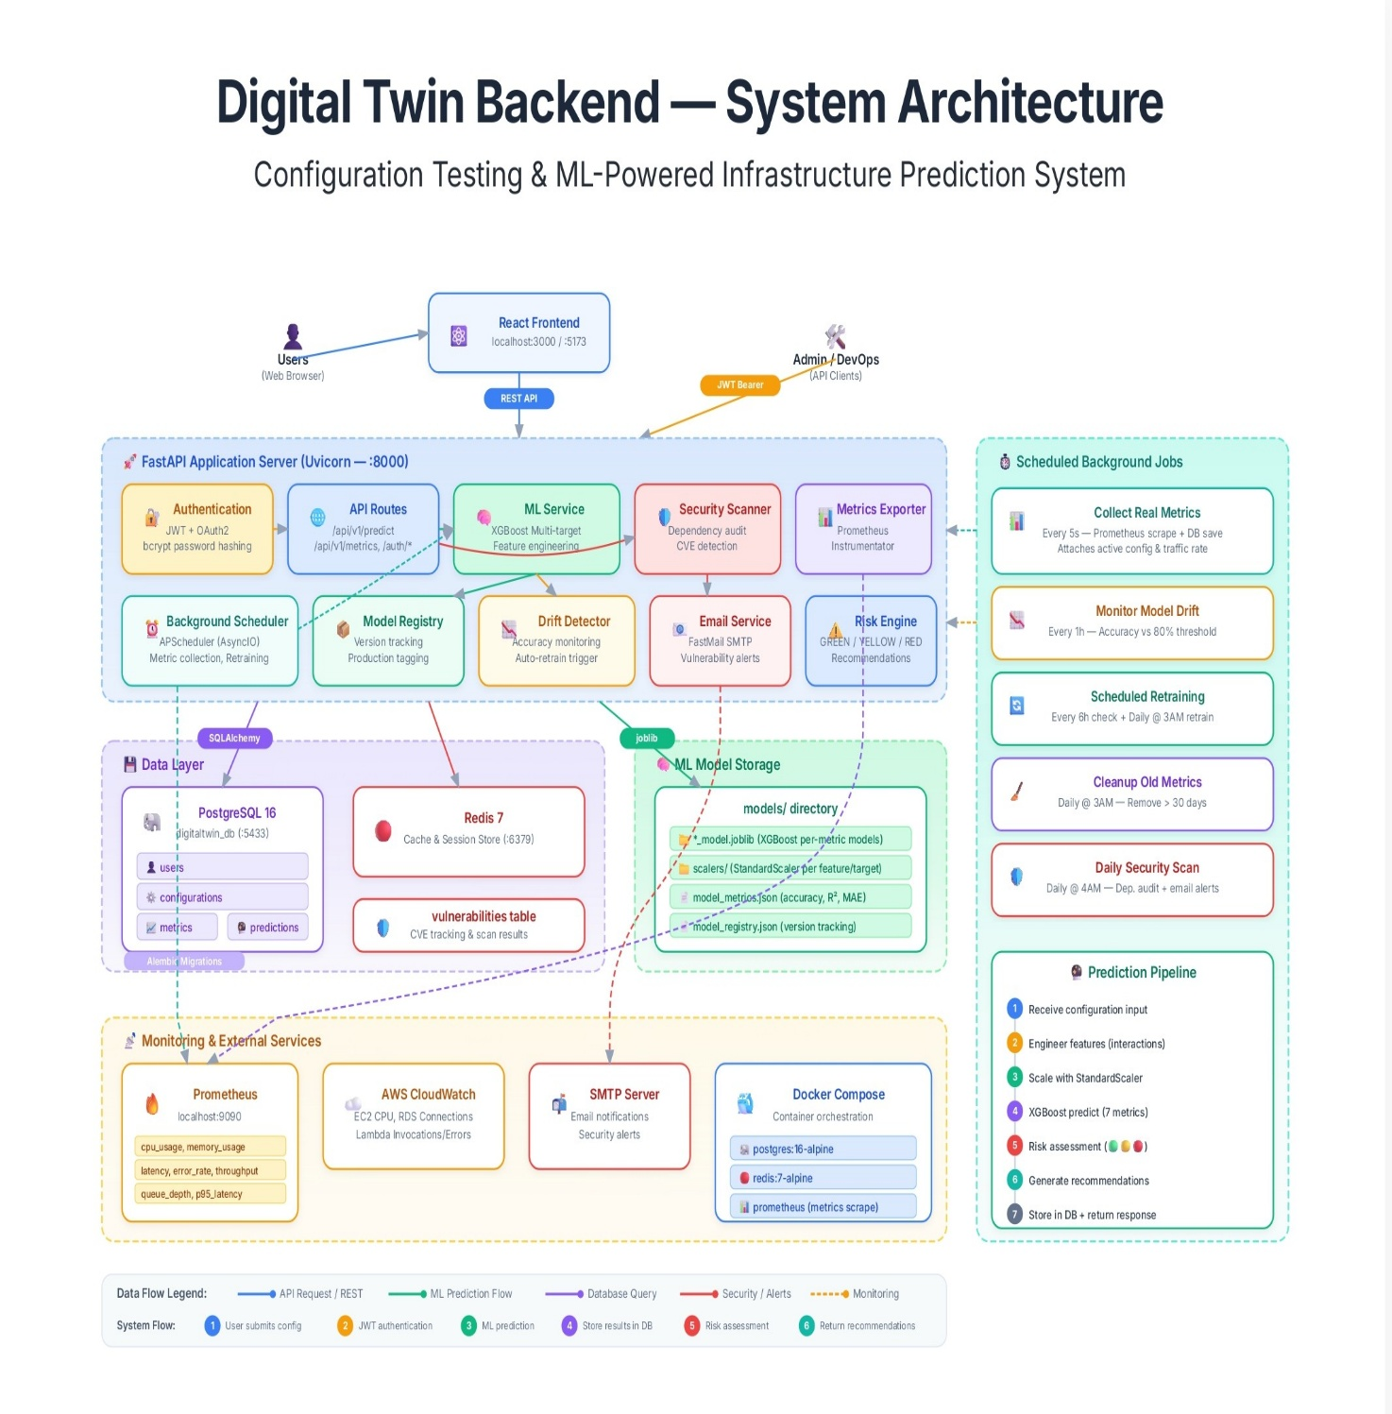

Figure 2: Workflow
